Social Consultancy Services

CHILD BUDGET STATEMENT
Government of Rajasthan

Contents
Background: 2
Introduction 4
The state of Rajasthan 4
Status of Children: 5
SOP / Templates of other state governments 7
Uttar Pradesh 8
Assam 8
Maharashtra 8
Karnataka 8
Child Budget in Rajasthan 9
Limitations of the current Child Budget Statement: 11
Proposed Model/Format for Child Budget Statement: 13
Rajasthan Child Budget Statement: 18
Annexures to the Budget: 32
1. Ministry-wise Expenditure: 32
2. Theme-wise Expenditure: 32
3. Breakdown on basis of categories: 33
Highlights of Child Budget 2021-22: 34
Significance of the proposed format: 37
Limitations of the proposed format: 37
Conclusions and Recommendations: 37
References: 39

Background:
The United Nations Convention on the Rights of Children (1989) defines the child as a person under 18 years of age. After the ratification of UNCRC in 1992, Indian Government has enacted many progressive Acts and policies to further the basic rights of children enshrined in the constitution, including National Policy for Children 2013. Through this policy, the State is committed to take affirmative measures – legislative, policy or otherwise – to promote and safeguard the rights of all children to live and grow with equity, dignity, security and freedom, to ensure that all children have equal opportunities; and that no custom, tradition, cultural or religious practice is allowed to violate or restrict or prevent children from enjoying their rights
Rights of children guaranteed by the Constitution of India  (i) Right to free and compulsory elementary education for all children between the age group 6-14 years. (Article 21A)  (ii) Right to be protected from any hazardous employment till the age of 14 years (Article 24)  (iii) Right to be protected from being abused and forced by economic necessity to enter occupation unsuited to their age or strength [Article 39(e)]  (iv) Right to equal opportunities and facilities to develop in a healthy manner and in condition of freedom and dignity and guaranteed protection of childhood and youth against exploitation and against moral and material abandonment [Article 39(f)] | Acts protecting the rights of children  - Right to Education Act 2009  - The Protection of Children from Sexual Offenses Act 2012 /The Protection of Children from Sexual Offenders (Amendment) Act 2019.  - The Juvenile Justice Care and Protection of Children Act 2000  - Child Labour (Prohibition and Regulation) Amendment Act, 2016.  - Pre-Conception and Pre-Natal Diagnostic Techniques Act (PCPNDT) Act 1994  - Registration of Birth and Death Act 1969  - The Prohibition of Child Marriage Act, 2006  - The Commissions for Protection of Child Rights Act, 2005/ The Commissions for Protection of Child Rights Amendment Act, 2006

In pursuance of these constitutional provisions and Acts, Union and State Government budgets reflect allocation of resources in the form of centrally sponsored schemes and programmes under various ministries.
The National Policy for Children incorporates these promises under key priorities, thematic areas of action that include survival, health and nutrition, education and development, and protection. Among the guiding principles, priorities and recommended implementation framework, under section 8 includes the requirement for the state to commit the required financial material and human resources and their efficient and effective use with transparency and accountability. That Child Budgeting will track allocation and utilization of resources and their impact on outcomes for children.
The primary objective of the Child budget analysis is to ascertain progress, challenges and opportunities for improving the quality and quantity of public spending on children. Apart from providing information on whether spending on children is increasing or decreasing and is adequate or not, it also demonstrates the revenue architecture and trends to gauge fiscal space available to improve public spending on children.
Specifically, child budget looks into:
- The share of children in the total state budget and in the social sector budget?
- The share of sector-wise allocations and spending?
- The trends in expenditure between budget estimates, revised estimates and actual expenditure?

These numbers and trends, in turn, have to be understood against the following queries:
- Has the state mapped and identified all the needs, challenges and priorities for children who are most vulnerable and where they reside?
- Do the allocation and expenditure trends correlate with the state’s commitment towards the key priorities of the NPC?
- Are the allocations commensurate with the programme and policy intent?
- What is the gap between allocation and utilization and the gap outlays and outcomes?

Introduction
The policies and priorities of the respective Governments are accentuated through budget and therefore, the objective of developing a Standard Operating Procedure (SOP) is to understand how resource allocation contributes to the realization of children's rights by supporting the best possible use of public budgets. Article 4 of the United Nations Convention of the Rights of the Child (UNCRC) places an obligation on all governments to ensure that they commit national and global resources to the `maximum extent'. This document tries to suggest a possible Standard Operating Procedure (SOP) for preparing the child budget statement (CBS) in Rajasthan.
The child budget statement is an important document to track the budget allocation and expenditure for children as well as their impacts and outcomes under concerned programmes of different concerned departments/ministries. The union government and some state governments like Uttar Pradesh, Bihar, Assam, Kerala have or in the process of preparing the child budget statements (CBS).
This SOP is based on the secondary data analysis and by referring to some of the key documents including the child budgeting template of UP, Bihar, Budget Preparation Guideline of Assam (2018-19), the Roadmap for Gender and Child Budgeting in Maharashtra, and the 2020-21 budget circular of union govt. and its reconstitution and strengthening of Gender Budget Cell as Gender and Child Budget Cell. This proposed SOP suggests the ways for preparing the CBS of the state as well as suggesting the format for CBS in Rajasthan.

The state of Rajasthan
Rajasthan is largest state of India by area, is located on the north –west and shares its border with Pakistan, and with Gujarat, Haryana, Punjab and UP among the Indian states. The state has 33 districts spread over 3.46 lakh square Km, accounting 10.4% of the total geographical area of the country. Total population of the state is 68.48 lakh, which is about 5.66% of country’s total population. The state is divided into seven divisions i.e. Jaipur, Jodhpur, Udaipur, Bharatpur, Ajmer, Kota and Bikaner. Between the extreme temperatures, regional disparities in water supply and resources, swathes of inaccessible regions, a growing population and urban migration. With the state navigating its priorities between economic growth and sustainability, regions of mining, desertification, unemployment, and poverty. All pose complex challenge in addressing the essential needs of the children of the state.

Status of Children:
Rajasthan is a largely young state with percentage of population between 0-18 being 43.6% (29 million) significantly higher than the national average of 39%. This characteristic extends across the various age groups including 0-6 (15.5%) and 0-14 (34.6%). However, this youthful population is marred by a poor sex ratio where 0-6 is 888, 0-18 is 887 and across all ages it is 928 – compared to the national figures of the same criteria are 918, 908 and 943. However, an alarming trend that has been developing since 2011 to 2015 is the sharp decline in sex ratio at birth, which has declined from 911 to 794, additionally the sex ratio between age 0-6 is better in rural Rajasthan with 897 than urban at 852. These figures are bolstered by the significantly higher than average % of registration of births in Rajasthan which has increase incrementally from a high 96.7% to 98.7% between 2011-15.
Infant mortality rate of Rajasthan is 41, compared to the Indian average of 34 it is considerably high especially considering the exceptionally high institutional births. Both urban (30) and rural (45) IMR are higher in their respective national averages. This characteristic repeats with neo-natal mortality of 28 compared to the national average of 28 and U5MR of 45 in the state and 39 being the national average indicating a larger problem with the obstetric care provided across the board.
The nutritional status of children in the state paints an average picture. Rajasthan’s under 5 stunted, wasted and underweight figures are 39.1, 23.0 and 36.7 respectively. These figures are close to the national figures of 38.4, 21.0 and 35.7. With anaemia there is a similar match with state a national average, being 60.3 and 58.4 respectively. The prevalence and range of severity of anaemia among children also follow the national average.
With regards to the gross enrolment ratio of children across primary, upper primary, secondary and higher secondary as per DISE 2015-16 data. Rajasthan performs consistently better against national average at sending its boys for education compared to its girls which consistently lag behind to varying degrees across the board but most notably at secondary level. As a total across the tiers of education at the state and national the GER at primary level is 100.43 for Rajasthan and 99.21 for India, at upper primary level it is 91.34 and 92.81 respectively, at secondary level it is 76.06 and 80.01 and at higher secondary it is 59.31 and 56.16 respectively. This reflects a declining gender parity index in Rajasthan, which goes from 0.98 to 1.00 to 0.99 to 0.86 and 0.78 across the aforementioned levels of education. This decline is greater in the state than the equivalent Indian average which remains above 1.00 across the board.
According to an IMRB study about 3% of the children are out of school. There are about 6% of the primary schools with just one room, and about 30% of the primary schools are with single teacher, while one third of the primary schools are without boundary wall or all-weather roads as per DISE data. DISE data also suggest that drop out among the primary school (classes I-V) children is as high as 5% while it is 3% among the upper primary (classes VI-VIII) children.
The protection of children has been a priority of Rajasthan, it has brought its incidence of child labour in age group 5-9 to 2.22% when compared to 2% India average, and between age group 10-14 there is 4.8% of children in child labour compared to 5.73 nationally. It is to be noted that in the latter age group there are more girls involved in child labour, 5.66 girls compared to 3.71%. Though the crimes against children have been on the rise between the year 2014-2016 from 3880 to 4032 reported incidents under IPC an SLL, this represents a 14.1% crime rate against children as compare to the national average of 24%. Crimes committed by juveniles is on par with national average at 8%.
Child marriage though largely reduced from its previous levels of prevalence is a violation of the protection right of children and leaves negative impact on physical growth, health, mental and emotional development and educational opportunities. Data on child marriage in India come from various sources like Census, National Family Health Survey (NFHS), and India Human Development Survey (IHDS). According to the Census data, the 59.4% of total women were married before the age of 18 in the year 2001 which declined to 42.6% in 2011. The state continues to make steady but unremarkable progress across the various indicators. However, its adherence with national averages across the board indicates consistent effort towards improvement, with additional effort the existing systems would be stimulated to produce better results.

SOP / Templates of other state governments
CBS at the state level serves a more specific function with several benefits. It begins with a greater level of financial accountability of the state towards its children, this process would generate data sets that would allow comparisons between states and what the best practices can be. The process of State CBS would encourage the generation of much needed regional data that would in turn be consolidated and make a valuable contribution towards national statistics. The states would be inclined to better evaluate the regional needs of their children and that would be reflected in their state budget with customizations to schemes making them more regionally relevant. Lastly a State CBS would be more in line with India’s democratic spirit, as the state would be accountable to meet the regional aspirations of its people and have it reflected in the budget.
The SOP/Guidelines of the other states, which have developed child budget statement, have developed a template / format for the CBS in their respective states.
The Ministry of Women and Child Development on two occasions has produce a Gender Budgeting Handbook in 2007 and 2015. With the consolidation of CBS with GBS their methodology of implementation from National recommendations remains identical. The States that have implemented a form of CBS are iterating on these recommendations.
The salient features of the recommended methodology include:
- Mapping of forms of discrimination, abuse and risks through the life cycle of the child and matching it potential risks with regional realities.
- Listing of Ministries and Departments with relevance to CBS
- Advises on how CBS can be injected into the budget preparation stage, when the budget is tabled, the implementation of budget and post implementation. It shows a 5 Step framework for CBS leading to an outcome budget.
  - Participatory Planning and Budgeting
  - Spatial Mapping
  - Child Appraisal for all programs and schemes
  - Guidelines for child sensitive review of public expenditure and policy
  - Child based profile of public expenditure
  - Creation of Outcome Budget
- Lists a series of pre-requisites required to implement CBS, including sensitizing stakeholders, developing regional concepts and tools, creating a child relevant database.
- The handbook notes that there are two categories of schemes, those that are 100% child centric and those that are 33-99% child centric.
Following are the few examples of state specific child budgeting process.

Uttar Pradesh
In the Annual Budget of Uttar Pradesh, nine Departmental Grants are identified with specific contributions to children’s welfare, which include 178 budget heads across these grants.

Assam
The Assam government child budget is divided in two parts:
In Part A of the Format for Child Budget Statement, the departments should report entire budget outlays for institutions/ schemes/ programmes that are meant exclusively or largely for children.
In Part B of the Format for Child Budget Statement, the departments should report budget outlays meant for child-specific components (if any) within other institutions/ schemes/ programmes.
The figures reported in the Child Budget Statement must be consistent with those in the respective departments’ Detailed Demands for Grants (DDGs) and Statements of Allocations to be uploaded on FinAssam portal.

Maharashtra
According to the ‘Roadmap….’ The child budget statement should be divided into two parts – Part A and Part B. The PART A is further divided into part A1 and part A2. Part A1 lists the schemes/programmes with 100% direct expenditure on children, while part A2 lists the schemes with less that 100% direct expenditure on children. The part B lists the schemes with indirect expenditure on children. The child budget statement of Maharashtra for the year 2020-21, however, provides only the parts A1 and A2.

Karnataka
The Karnataka government’s Child Budget statement is one of the most comprehensive documents. It identifies all the relevant budget heads and categorizes them on basis of two criteria, creating an extremely granular data. This can be used to establish quantitative differentiation of schemes and also identify different categories of heads within the same scheme. It provides for separate publishing of all the four categories of heads.
But in none of the above-mentioned states except Karnataka, the child budget statement is separately published or annexed with the annual budget statement. The statements just provide a total for all the schemes in both parts (A1 and A2 in Maharashtra and A and B in Assam).

Child Budget in Rajasthan
First child budget statement for Rajasthan for the FY 2020-21. The Department of Women and Child Development has been made a nodal agency for the child budgeting in the state. Proposed to expand the Gender Cell as Gender and Child Budget Cell and reorganizing the Gender Desks as Gender and Child Desks. The Budget Circular issued by the government on September 5, 2019 for the FY 2020-21 has asked the respective departments to furnish information regarding the schemes/programmes for children in the following format:
Child Budget Statement
(Description of outlays of schemes for Education, Health, Protection and Development related schemes for children below the age of 18)
Department Name |  |  | BFC Unit Number
Serial No. | Scheme Name | Budget Estimate 2019-20 | Revised Estimate 2019-20 | Budget Estimate 2020-21
1 | 2 | 3 | 4 | 5
1
2
3
 | Total
Certified that the aforementioned information has been verified by me and has found to be correct
 |  |  |  | Office Head

Limitations of the current Child Budget Statement:
While the budget is extremely exhaustive in scope and coverage of total outlay and all schemes, there are a few issues in the statement which limit its utility. To assess how the utility of the statement is limited in its current form, we need to revisit the objective of having a child budget statement to begin with.
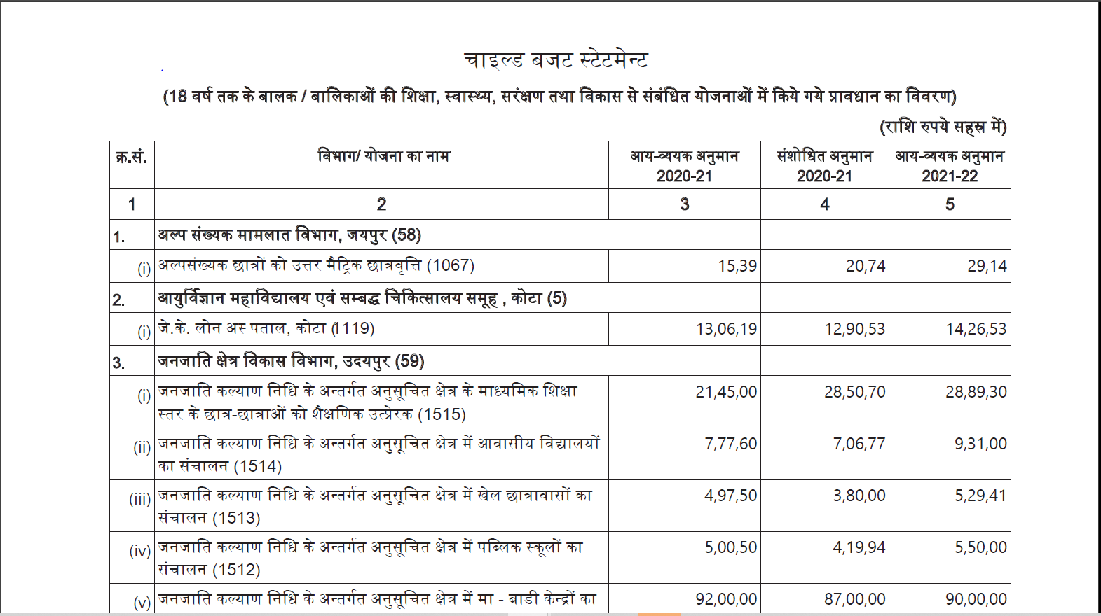
The idea behind the child budget statement was to improve utilization of funds allocated for development of children, to monitor the funds being allocated and with increase in budget utilization efficiency subsequently increase the outlay for development of children.
Keeping in mind these broad objectives, in its current form, the child budget statement has a number of limitations:
- The budget statement has mentioned allocations for different schemes with their scheme codes. However, the scheme codes mentioned are not related to the budget heads from the budget. This makes the process of monitoring the schemes or identifying the breakdown of the allocation for the schemes difficult.
- The schemes are categorised on the basis of departments probably keeping in view operational efficiency. However, such categorization subsumes the schemes of departments like Social Justice and Empowerment or Women and Child Development or Department of Tribal Affairs into a single unit. Such ministries have schemes that target more than one themes of child development. Therefore, it becomes difficult to assess the thematic areas and the extent to which the budget has provisioned for.
- In its current form, the statement does not give any idea on the nature of cost incurred. The expenditure heads in the statement includes scholarships, scheme funds and also generic schemes that contribute to development of multiple stakeholders including children like NCC or RCH focussed medical facilities or schemes for the differently abled. In its current form, the schemes do not indicate if the outlay for a scheme exclusively target welfare of children or any contribution for development of children is a component of the scheme. This tends to overestimate the contribution of the budget to child development. Ideally, such schemes which only have a part focus on child development should be differentiated and the outlay should get weighted on pro-rata basis. However, considering it would require case by case consideration, a qualitative differentiation of schemes that are completely focused on welfare of children (100%) and scheme that only partially target welfare of children (less than 100%) is warranted.
- Similarly, the budget also lacks the granularity to mention if the expenditure incurred is directed towards children including direct payment in form of scholarship or is directed at facilitating consumption of goods and services like maintenance of infrastructure, administrative costs or expenditure on educational motivation through indirect payment. While this may not quantitatively inflate estimated child budget size, it can qualitatively suggest that the budget is way more incisive and impactful than it actually is. Therefore, the differentiation between such schemes that target directly and indirectly at welfare of children is necessary.
- Finally, from a logistical point of view, the budget documents and the Integrated Financial Management System (IFMS) have numerous technical issues that impede objective analysis of the budget. To mention a few:
  - The documents that are uploaded on the websites are not available in editable file forms like Excel, but in PDF form which makes data cleaning and editing a tedious process.
  - Even if the documents are uploaded as a PDF, these files are scanned copies of images and not text converted PDF, due to which data can not be selected off these pages.
  - The IFMS RajKosh does not provide a compilation of budget heads within a Major head, but only individual budget head. For compiling all the data under different heads under a major head one has to individually fill up the details of the heads, which makes the task practically impossible.
- The current statement does not share indicative details that may be relevant such as proportion of different themes, or total number of schemes within important ministries or their respective outlays. This makes the process of monitoring and establishing trends in budget outlays difficult.

Proposed Model/Format for Child Budget Statement:

To overcomes the limitations in the current Child Budget Statement and to increase its utility as a policy tool for government and civil society, a new format for Child Budget Statement is recommended. This model is developed on the existing format based on the scheme code. Therefore, the structural unit of the budget are the schemes as in the existing format. Following are the major features of the format:

- Identification and Categorization of Schemes: For the four-fold divisions of the schemes, all the schemes mentioned in the budget were enumerated. The nature of these schemes was analysed on following basis:
  - whether the benefits of the schemes are passed on to children directly in form of consumption, cash payment or incentive or whether the benefits are targeted to improve access to social services in forms of infrastructure creation.
  - among these schemes, ones which are solely targeting one or more themes of child rights were identified while schemes that are not child centric in principle but have an aspect that involves expenditure on children were identified.
- The format focuses on classification of the schemes on the basis of the sector or theme of child development the schemes are targeting. This is in deviation to the existing format where the schemes are classified on the basis of their respective departments. In this format there are 4-5 recommended themes in which the statement is divided. These themes are Education, Health, Nutrition, Protection and Participation. Considering Education forms a major chunk and participation has very few heads, it can be subsumed with Protection or Education depending on the commonality of departments responsible.
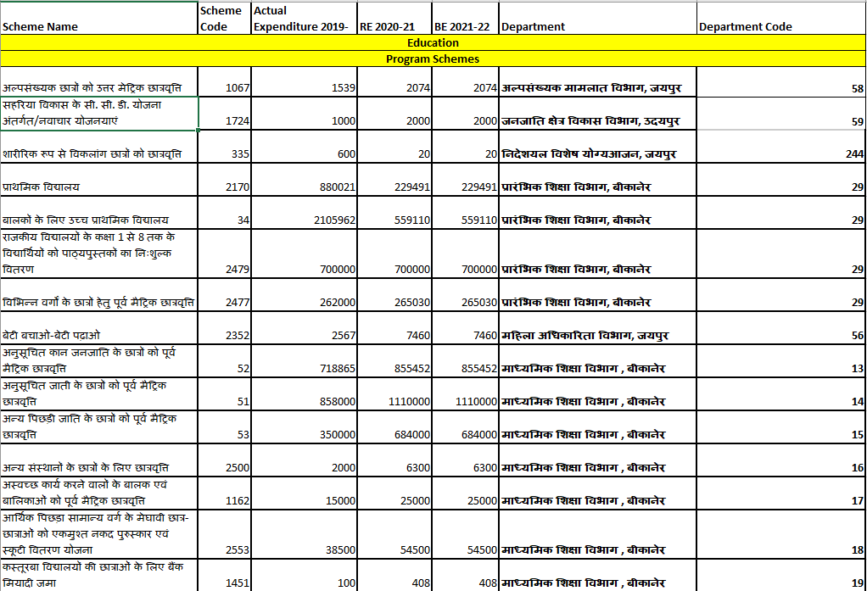

- The format also indicates the department and its code for each scheme to prevent any loss of information from the existing format.

- Within each thematic classification, we have divided the schemes into two categories: “Program” and “Non-program”. This differentiation has been discussed previously. The concept is also followed in the Karnataka Child Budget Statement. In summary, the “Program” schemes are schemes that directly benefit children through nutrition or scholarships. Similarly, “Non-Program” schemes include schemes that deal with institutional set ups, establishments, infrastructure facilities and administrative support that benefit children.
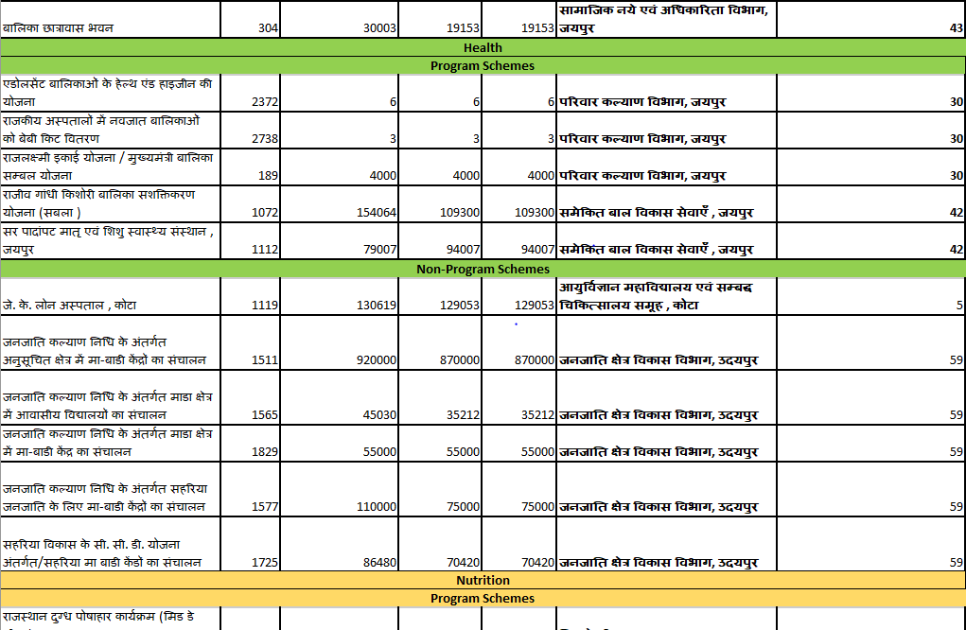

- Another differentiation that is followed in the Karnataka Child Budget Statement is the identification of schemes with 100% contribution and less than 100% contribution.
Such differentiation of schemes can be mentioned in annexures or not be considered, since in case of Rajasthan child budget, schemes that contribute to less than 100% are very few. Such differentiation is practical choice for Karnataka child budget statement but might not be for Rajasthan because the Karnataka child budget is published and noted based on the 13-digit budget head and not the 4-digit scheme code used in Rajasthan budget.

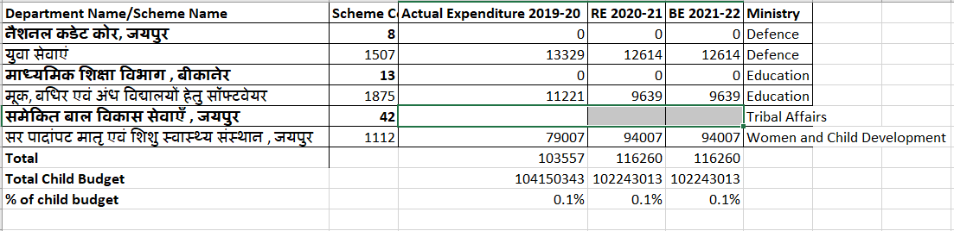

- Elaborating on the point mentioned considering the scheme codes sum up all the budget heads within the scheme, the categorization of the schemes is limited to program and non-program. Meanwhile in the Karnataka Child Budget Statement, because the structural unit are the budget codes for each head, it is more granular and provides an opportunity to divide the schemes on basis of more categories. Similarly, it allows further for quantitative differentiation of schemes.

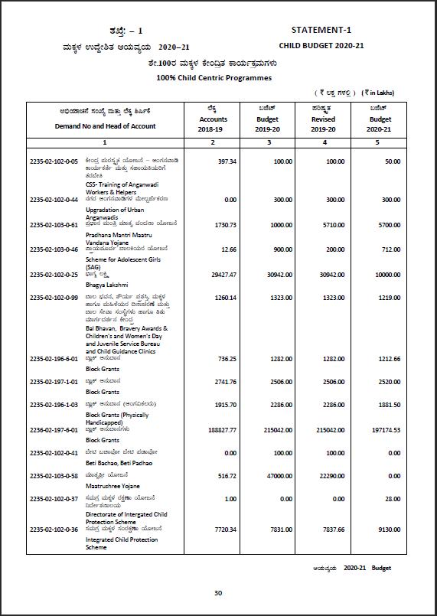

- Apart from the format mentioned, as annexures or extension to existing documents, data on the categories of the schemes can be mentioned. This includes:
  - Breakdown of Program and Non-Program, 100% and less than 100% schemes
  - Summary of all four categories
  - Ministry-wise breakdown and summary of contribution
  - Theme-wise breakdown and summary of contribution
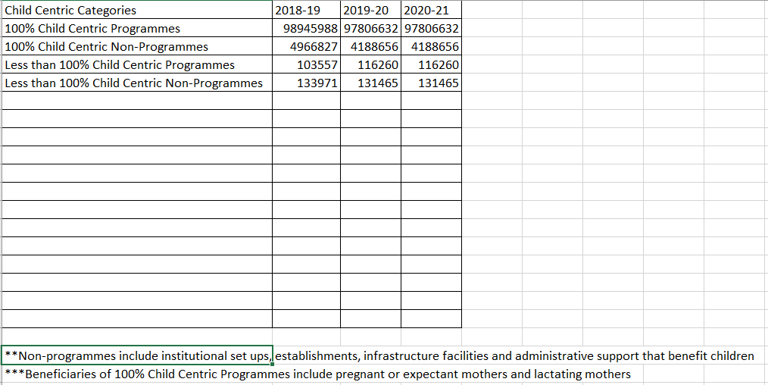

Rajasthan Child Budget Statement:

Scheme Name | Scheme Code | Actual Expenditure 2019-20 | RE 2020-21 | BE 2021-22 | Department | Department Code
Education
Program Schemes
अल्पसंख्यक छात्रों को उत्तर मेट्रिक छात्रवृत्ति | 1067 | 1539 | 2074 | 2074 | अल्पसंख्यक मामलात विभाग, जयपुर | 58
सहरिया विकास के सी. सी. डी. योजना अंतर्गत/नवाचार योजनयाएं | 1724 | 1000 | 2000 | 2000 | जनजाति क्षेत्र विकास विभाग, उदयपुर | 59
शारीरिक रूप से विकलांग छात्रों को छात्रवृत्ति | 335 | 600 | 20 | 20 | निदेशयल विशेष योग्यआजन, जयपुर | 244
प्राथमिक विद्यालय | 2170 | 880021 | 229491 | 229491 | प्रारंभिक शिक्षा विभाग, बीकानेर | 29
बालकों के लिए उच्च प्राथमिक विद्यालय | 34 | 2105962 | 559110 | 559110 | प्रारंभिक शिक्षा विभाग, बीकानेर | 29
राजकीय विद्यालयों के कक्षा 1 से 8 तक के विद्यार्थियों को पाठ्यपुस्तकों का निःशुल्क वितरण | 2479 | 700000 | 700000 | 700000 | प्रारंभिक शिक्षा विभाग, बीकानेर | 29
विभिन्न वर्गों के छात्रों हेतु पूर्व मैट्रिक छात्रवृत्ति | 2477 | 262000 | 265030 | 265030 | प्रारंभिक शिक्षा विभाग, बीकानेर | 29
बेटी बचाओ-बेटी पढ़ाओ | 2352 | 2567 | 7460 | 7460 | महिला अधिकारिता विभाग, जयपुर | 56
अनुसूचित कान जनजाति के छात्रों को पूर्व मैट्रिक छात्रवृत्ति | 52 | 718865 | 855452 | 855452 | माध्यमिक शिक्षा विभाग , बीकानेर | 13
अनुसूचित जाती के छात्रों को पूर्व मैट्रिक छात्रवृत्ति | 51 | 858000 | 1110000 | 1110000 | माध्यमिक शिक्षा विभाग , बीकानेर | 14
अन्य पिछड़ी जाति के छात्रों को पूर्व मैट्रिक छात्रवृत्ति | 53 | 350000 | 684000 | 684000 | माध्यमिक शिक्षा विभाग , बीकानेर | 15
अन्य संस्थानों के छात्रों के लिए छात्रवृत्ति | 2500 | 2000 | 6300 | 6300 | माध्यमिक शिक्षा विभाग , बीकानेर | 16
अस्वच्छ कार्य करने वालों के बालक एवं बालिकाओं को पूर्व मैट्रिक छात्रवृत्ति | 1162 | 15000 | 25000 | 25000 | माध्यमिक शिक्षा विभाग , बीकानेर | 17
आर्थिक पिछड़ा सामान्य वर्ग के मेघावी छात्र-छात्राओं को एकमुश्त नकद पुरुस्कार एवं स्कूटी वितरण योजना | 2553 | 38500 | 54500 | 54500 | माध्यमिक शिक्षा विभाग , बीकानेर | 18
कस्तूरबा विद्यालयों की छात्राओं के लिए बैंक मियादी जमा | 1451 | 100 | 408 | 408 | माध्यमिक शिक्षा विभाग , बीकानेर | 19
कारगिल पूर्व सैनिकों के बालक एवं बालिकाओं को पूर्व मैट्रिक छात्रवृत्ति | 54 | 10 | 4 | 4 | माध्यमिक शिक्षा विभाग , बीकानेर | 20
ग्रामीण बालिकाओं के लिए साइकिल वितरण | 1457 | 1150000 | 484358 | 484358 | माध्यमिक शिक्षा विभाग , बीकानेर | 21
छात्र बीमा | 1459 | 26249 | 26249 | 26249 | माध्यमिक शिक्षा विभाग , बीकानेर | 22
बालकों के लिए माध्यमिक विद्यालय | 55 | 56257700 | 57563594 | 57563594 | माध्यमिक शिक्षा विभाग , बीकानेर | 23
बालिकाओं के लिए माध्यमिक विद्यालय | 56 | 0 | 0 | 0 | माध्यमिक शिक्षा विभाग , बीकानेर | 24
मूक, बधिर एवं अंध विद्यालयों हेतु सॉफ्टवेयर | 1875 | 11221 | 9639 | 9639 | माध्यमिक शिक्षा विभाग , बीकानेर | 25
राजकीय विद्यालयों के कक्षा 9 से 12 तक के विद्यार्थियों को पाठ्यपुस्तकों का निःशुल्क वितरण | 2492 | 300000 | 480001 | 480001 | माध्यमिक शिक्षा विभाग , बीकानेर | 26
राज्य प्रतिभा खोज परीक्षा छात्रवृत्ति | 2316 | 2000 | 2000 | 2000 | माध्यमिक शिक्षा विभाग , बीकानेर | 27
लैपटॉप वितरण (माध्यमिक शिक्षा ) | 1733 | 480000 | 3 | 3 | माध्यमिक शिक्षा विभाग , बीकानेर | 28
सराहनीय (मेरितोरियस) छात्राओं हेतु प्रोत्साहन | 1450 | 500000 | 45070 | 45070 | माध्यमिक शिक्षा विभाग , बीकानेर | 29
सांस्कृतिक शैक्षिक भ्रमण | 1460 | 2500 | 1 | 1 | माध्यमिक शिक्षा विभाग , बीकानेर | 30
सैनिक स्कूल चित्तोडगढ़ | 2654 | 45000 | 10000 | 10000 | माध्यमिक शिक्षा विभाग , बीकानेर | 31
सैनिक स्कूल झुनझुनू | 2655 | 360000 | 360000 | 360000 | माध्यमिक शिक्षा विभाग , बीकानेर | 32
सैनिक स्कूलों के छात्रों के लिए छात्रवृत्ति | 2499 | 21393 | 21393 | 21393 | माध्यमिक शिक्षा विभाग , बीकानेर | 33
मदरसा स्कूल | 43 | 627400 | 648000 | 648000 | राजस्थान वक्फ बोर्ड, जयपुर | 229
अजा / अजजा गैर अधिसूचित जातियों के बच्चों के लिए व्यक्तिगत या सामान्य छात्रावास | 379 | 11000 | 5000 | 5000 | सामाजिक नये एवं अधिकारिता विभाग, जयपुर | 43
अनुसूचित जनजाति के लिए उत्तर छात्रवृत्ति | 2529 | 2850000 | 2850000 | 2850000 | सामाजिक नये एवं अधिकारिता विभाग, जयपुर | 44
अनुसूचित जाति के लिए उत्तर छात्रवृत्ति | 2528 | 4473200 | 5313200 | 5313200 | सामाजिक नये एवं अधिकारिता विभाग, जयपुर | 45
अन्य पिछड़ा वर्ग के छात्रों के लिए उत्तर छात्रवृत्ति | 2530 | 817464 | 917664 | 917664 | सामाजिक नये एवं अधिकारिता विभाग, जयपुर | 46
आर्थिक पिछड़े वर्ग के छात्रों के लिए उत्तर मेट्रिक छात्रवृत्ति योजना | 2700 | 500 | 1 | 1 | सामाजिक नये एवं अधिकारिता विभाग, जयपुर | 47
छात्रवासियों को साइकिल वितरण योजना | 2541 | 10001 | 1 | 1 | सामाजिक नये एवं अधिकारिता विभाग, जयपुर | 48
पशु पालकों के बच्चों के लिए योजना | 2453 | 1700 | 1 | 1 | सामाजिक नये एवं अधिकारिता विभाग, जयपुर | 49
पशु पालकों के बच्चों के लिए आवासीय विद्यालय | 373 | 43551 | 46650 | 46650 | सामाजिक नये एवं अधिकारिता विभाग, जयपुर | 50
पुस्तक बैंक | 279 | 1200 | 900 | 900 | सामाजिक नये एवं अधिकारिता विभाग, जयपुर | 51
रेबारी एवं अन्य भ्रमणशील समुदायों के परिवार के बच्चों के लिए आवासीय विद्यालय | 388 | 26668 | 45000 | 45000 | सामाजिक नये एवं अधिकारिता विभाग, जयपुर | 52
Non-Program Schemes
जनजाति कल्याण निधि के अंतर्गत अनुसूचित क्षेत्र के माध्यमिक शिक्षा स्तर के छात्र-छात्राओं को शैक्षणिक उत्प्रेरक | 1515 | 214500 | 285070 | 285070 | जनजाति क्षेत्र विकास विभाग, उदयपुर | 59
जनजाति कल्याण निधि के अंतर्गत अनुसूचित क्षेत्र में आवासीय विद्यालयों का संचालन | 1514 | 77760 | 70677 | 70677 | जनजाति क्षेत्र विकास विभाग, उदयपुर | 60
जनजाति कल्याण निधि के अंतर्गत अनुसूचित क्षेत्र में खेल छात्रवासों का संचालन | 1513 | 49750 | 38000 | 38000 | जनजाति क्षेत्र विकास विभाग, उदयपुर | 61
जनजाति कल्याण निधि के अंतर्गत अनुसूचित क्षेत्र में पब्लिक स्कूलों का संचालन | 1512 | 50050 | 41994 | 41994 | जनजाति क्षेत्र विकास विभाग, उदयपुर | 62
जनजाति कल्याण निधि के अंतर्गत अनुसूचित क्षेत्र में आश्रम छात्रावासों का संचालन | 42 | 779464 | 748230 | 748230 | जनजाति क्षेत्र विकास विभाग, उदयपुर | 63
जनजाति कल्याण निधि के अंतर्गत कक्षा 1 से 5 तक के सहरिया छात्र-छात्राओं को शैक्षणिक उत्प्रेरक | 1568 | 6000 | 6000 | 6000 | जनजाति क्षेत्र विकास विभाग, उदयपुर | 64
जनजाति कल्याण निधि के अंतर्गत भिखरे क्षेत्र के माध्यमिक शिक्षा स्तर के छात्र-छात्राओं को शैक्षणिक उत्प्रेरक | 1601 | 29500 | 51000 | 51000 | जनजाति क्षेत्र विकास विभाग, उदयपुर | 65
जनजाति कल्याण निधि के अंतर्गत भिखरे क्षेत्र में छत्रवासों का संचालन | 1595 | 45610 | 34360 | 34360 | जनजाति क्षेत्र विकास विभाग, उदयपुर | 66
जनजाति कल्याण निधि के अंतर्गत माडा क्षेत्र के आश्रम छात्रावासों का संचालन | 1564 | 156750 | 119034 | 119034 | जनजाति क्षेत्र विकास विभाग, उदयपुर | 67
जनजाति कल्याण निधि के अंतर्गत माडा क्षेत्र के माध्यमिक शिक्षा स्तर के छात्र-छात्राओं को शैक्षणिक उत्प्रेरक | 1569 | 29400 | 71000 | 71000 | जनजाति क्षेत्र विकास विभाग, उदयपुर | 68
जनजाति कल्याण निधि के अंतर्गत समूह क्षेत्र के माध्यमिक शिक्षा स्तर के छात्र-छात्राओं को शैक्षणिक उत्प्रेरक | 1582 | 1224 | 1530 | 1530 | जनजाति क्षेत्र विकास विभाग, उदयपुर | 69
जनजाति कल्याण निधि के अंतर्गत सहरिया क्षेत्र के माध्यमिक शिक्षा स्तर के छात्र-छात्राओं को शैक्षणिक उत्प्रेरक | 1571 | 11500 | 11400 | 11400 | जनजाति क्षेत्र विकास विभाग, उदयपुर | 70
जनजाति कल्याण निधि के अंतर्गत सहरिया जनजाति के लिए आवासीय विद्यालयों का संचालन | 1566 | 83250 | 76010 | 76010 | जनजाति क्षेत्र विकास विभाग, उदयपुर | 71
जनजाति कल्याण निधि के अंतर्गत सहरिया जनजाति के लिए छात्रावासों का संचालन | 1607 | 63458 | 48376 | 48376 | जनजाति क्षेत्र विकास विभाग, उदयपुर | 72
भारत के संविधान के अनुच्छेद 275(1) के अंतर्गत एकलव्य मॉडल आवासीय विद्यालयों का संचालन | 1591 | 438889 | 189085 | 189085 | जनजाति क्षेत्र विकास विभाग, उदयपुर | 73
बालिका छात्रावासों की स्थापना | 1455 | 2000 | 1200 | 1200 | माध्यमिक शिक्षा विभाग , बीकानेर | 13
राष्ट्रीय प्रतिभा खोज परीक्षा का आयोजन | 1166 | 3000 | 3000 | 3000 | माध्यमिक शिक्षा विभाग , बीकानेर | 14
शिक्षा के अधिकार के अंतर्गत निजी विद्यालयों को पुनर्भरण ( आर. टी. आई. ) | 1486 | 18000 | 15300 | 15300 | संस्कृत शिक्षा विभाग, जयपुर | 11
आवासीय विद्यालयों का संचालन | 2567 | 320305 | 245055 | 245055 | सामाजिक नये एवं अधिकारिता विभाग, जयपुर | 43
छात्रावासों का अनुरक्षण | 277 | 1069702 | 780923 | 780923 | सामाजिक नये एवं अधिकारिता विभाग, जयपुर | 43
बालक छात्रावास भवन | 305 | 147502 | 84326 | 84326 | सामाजिक नये एवं अधिकारिता विभाग, जयपुर | 43
बालिका छात्रावास भवन | 304 | 30003 | 19153 | 19153 | सामाजिक नये एवं अधिकारिता विभाग, जयपुर | 43
Health
Program Schemes
एडोलसेंट बालिकाओं के हेल्थ एंड हाइजीन की योजना | 2372 | 6 | 6 | 6 | परिवार कल्याण विभाग, जयपुर | 30
राजकीय अस्पतालों में नवजात बालिकाओं को बेबी किट वितरण | 2738 | 3 | 3 | 3 | परिवार कल्याण विभाग, जयपुर | 30
राजलक्ष्मी इकाई योजना / मुख्यमंत्री बालिका सम्बल योजना | 189 | 4000 | 4000 | 4000 | परिवार कल्याण विभाग, जयपुर | 30
राजीव गांधी किशोरी बालिका सशक्तिकरण योजना (सबला ) | 1072 | 154064 | 109300 | 109300 | समेकित बाल विकास सेवाएँ , जयपुर | 42
सर पादांपट मातृ एवं शिशु स्वास्थ्य संस्थान , जयपुर | 1112 | 79007 | 94007 | 94007 | समेकित बाल विकास सेवाएँ , जयपुर | 42
Non-Program Schemes
जे. के. लोन अस्पताल , कोटा | 1119 | 130619 | 129053 | 129053 | आयुर्विज्ञान महाविद्यालय एवं सम्बद्ध चिकित्सालय समूह , कोटा | 5
जनजाति कल्याण निधि के अंतर्गत अनुसूचित क्षेत्र में मा-बाडी केंद्रों का संचालन | 1511 | 920000 | 870000 | 870000 | जनजाति क्षेत्र विकास विभाग, उदयपुर | 59
जनजाति कल्याण निधि के अंतर्गत माडा क्षेत्र में आवासीय विद्यालयों का संचालन | 1565 | 45030 | 35212 | 35212 | जनजाति क्षेत्र विकास विभाग, उदयपुर | 59
जनजाति कल्याण निधि के अंतर्गत माडा क्षेत्र में मा-बाडी केंद्र का संचालन | 1829 | 55000 | 55000 | 55000 | जनजाति क्षेत्र विकास विभाग, उदयपुर | 59
जनजाति कल्याण निधि के अंतर्गत सहरिया जनजाति के लिए मा-बाडी केंद्रों का संचालन | 1577 | 110000 | 75000 | 75000 | जनजाति क्षेत्र विकास विभाग, उदयपुर | 59
सहरिया विकास के सी. सी. डी. योजना अंतर्गत/सहरिया मा बाडी केंडों का संचालन | 1725 | 86480 | 70420 | 70420 | जनजाति क्षेत्र विकास विभाग, उदयपुर | 59
Nutrition
Program Schemes
राजस्थान दुग्ध पोषाहार कार्यक्रम (मिड डे मील ) | 2670 | 7260000 | 500000 | 500000 | मिड डे मील , राजस्थान | 284
राष्ट्रीय पोषाहार सहायता कार्यक्रम - मिड डे मील | 530 | 8149020 | 9525730 | 9525730 | मिड डे मील , राजस्थान | 284
पूरक पोषाहार | 391 | 6201424 | 8000000 | 8000000 | समेकित बाल विकास सेवाएँ , जयपुर | 42
Protection
Program Schemes
समेकित बाल संरक्षण योजना | 1219 | 593400 | 600000 | 600000 | निदेशालय बाल अधिकारिता विभाग | 259
विमण्डित मानसिक पीड़ित बच्चों के लिए गृह | 2591 | 40381 | 37831 | 37831 | निदेशयल विशेष योग्यआजन, जयपुर | 244
पालनहार योजना | 288 | 2600000 | 5709827 | 5709827 | सामाजिक नये एवं अधिकारिता विभाग, जयपुर | 43
Non-Program Schemes
शिशु गृह/क्रेच का संचालन | 2543 | 30000 | 25000 | 25000 | निदेशालय बाल अधिकारिता विभाग | 259
सम्प्रेषण/बाल गृह भवन | 986 | 12700 | 301 | 301 | निदेशालय बाल अधिकारिता विभाग | 259
विकलांगों का छिनहिकारण | 366 | 2102 | 2052 | 2052 | निदेशयल विशेष योग्यआजन, जयपुर | 244
शारीरिक तथा मानसिक पीड़ितों के क्षेत्र में कार्यकारी स्वैच्छिक अभिकरणों को सहायता | 2589 | 250 | 250 | 250 | निदेशयल विशेष योग्यआजन, जयपुर | 244
संभागीय मुखलयों पर मानसिक विमन्दितों हेतु पुनर्वास गृह | 1383 | 80000 | 117000 | 117000 | निदेशयल विशेष योग्यआजन, जयपुर | 244
Participation
Program Schemes
युवा सेवाएं | 1507 | 13329 | 12614 | 12614 | नैशनल कडेट कोर, जयपुर | 8
Non-Program Schemes
विकलांगों के लिए खेल कूद कार्यक्रम | 338 | 1000 | 110 | 110 | निदेशयल विशेष योग्यआजन, जयपुर | 244
Total |  | 104150343 | 102243013 | 102243013

Annexures to the Budget:

1. Ministry-wise Expenditure:

Ministry | 100% Program | <100% Program | 100% Non-Program | <100% Non-Program | Total | %age
 | Budget Estimate 2021-22
Education | 73515154 | 9639 | 19500 | 0 | ₹ 7,35,44,293 | 71.93%
Health | 4009 | 0 | 0 | 129053 | ₹ 1,33,062 | 0.13%
Women and Child Development | 8709300 | 94007 | 25301 | 0 | ₹ 88,28,608 | 8.63%
Tribal Affairs | 2000 | 0 | 2897398 | 0 | ₹ 28,99,398 | 2.84%
Social Justice and Empowerment | 14926095 | 0 | 1246457 | 2412 | ₹ 1,61,74,964 | 15.82%
Minority Affairs | 650074 | 0 | 0 | 0 | ₹ 6,50,074 | 0.64%
Defence | 0 | 12614 | 0 | 0 | ₹ 12,614 | 0.01%
Total |  |  |  |  | ₹ 10,22,43,013

2. Theme-wise Expenditure:
Budget Estimate 2021-22
Theme | 100% Program | less than 100% Program | 100% Non-Program | less than 100% Non-Program | Total | %age
Education | 73319935 | 9639 | 2940723 | 0 | ₹ 7,62,70,297 | 74.60%
Nutrition | 18025730 | 0 | 1105632 | 129053 | ₹ 1,92,60,415 | 18.84%
Health | 113309 | 94007 | 0 | 0 | ₹ 2,07,316 | 0.20%
Protection | 6347658 | 0 | 142301 | 2302 | ₹ 64,92,261 | 6.35%
Participation | 0 | 12614 | 0 | 110 | ₹ 12,724 | 0.01%
Total |  |  |  |  | ₹ 10,22,43,013 | 100.00%

3. Breakdown on basis of categories:

Child Centric Categories | 2019-20 AE | 2020-21 RE | 2021-22 BE
100% Child Centric Programmes | 98945988 | 97806632 | 97806632
100% Child Centric Non-Programmes | 4966827 | 4188656 | 4188656
Less than 100% Child Centric Programmes | 103557 | 116260 | 116260
Less than 100% Child Centric Non-Programmes | 133971 | 131465 | 131465

Highlights of Child Budget 2021-22:

The major highlights and results of the analysis of the Rajasthan Child Budget 2021-22 indicate trends in expenditures, contribution of ministries and expenditure in themes. The major points of discussion are mentioned here:
- The total size of the Child Budget is Rs. 10,000 Crore. It has remained consistent over the last three years with very small deviation of 1.83% from actual expenditure in 2019-20 to budget estimates of 2021-22.
- About 95% of the Child budget is categorized as “100% Program” Schemes, while about 4% of the Child budget was “100% Non-Program” and about 0.2% of the budget is <100% (program and non-program) combined.
This is the reason in the proposed format, the schemes are divided only on basis of “Program” and “Non-Program”
- Meanwhile, ministry-wise the total number of schemes across the 7 ministries- Education, Health, Women and Child Development, Social Justice and Empowerment, Tribal Affairs, Minority Affairs and Defence are:
Ministry | 100% Program | <100% Program | 100% Non-Program | <100% Non-Program | Total
Education | 27 | 1 | 3 | 0 | 31
Tribal Affairs | 1 | 0 | 20 | 0 | 21
Social Justice and Empowerment | 13 | 0 | 5 | 3 | 21
Women and Child Development | 3 | 1 | 2 | 0 | 6
Health | 3 | 0 | 0 | 1 | 4
Minority Affairs | 2 | 1 | 0 | 0 | 3
Defence | 0 | 1 | 0 | 0 | 1

- In terms of number of schemes, Education department has the highest number of schemes considering there are departments like “Prarambhik Shiksha” and “Madhyamik Shiksha”. Besides Education, Social Justice and Empowerment and Tribal Affairs have the highest number of schemes.
- In terms of expenditure, predictably 72% of the expenditure was incurred from Education ministry, while the 2nd highest contributor is Social Justice and Empowerment with 15.82% dominated by education for the vulnerable sections of the society, and Women and Child Development ministry is at 8.63% focusing on themes of nutrition and health.

- Theme-wise the expenditure is also dominated by Education (74.5%), followed by Nutrition (18.8%) and Protection (6.35%). These themes are characterized by outlays for flagship schemes like Samagra Shiksha, POSHAN and ICDS and Integrated Child Protection Program respectively. Health (0.20%) and Participation (0.1%) have very minute contributions.

Budget Estimate 2021-22
Theme | Total | %age
Education | ₹ 7,62,70,297.00 | 74.60%
Nutrition | ₹ 1,92,60,415.00 | 18.84%
Health | ₹ 2,07,316.00 | 0.20%
Protection | ₹ 64,92,261.00 | 6.35%
Participation | ₹ 12,724.00 | 0.01%
Total | ₹ 10,22,43,013.00 | 100.00%
Actual Expenditure 2019-20
Theme | Total | %age
Education | ₹ 7,75,82,528.00 | 74.49%
Nutrition | ₹ 2,29,57,573.00 | 22.04%
Health | ₹ 2,37,080.00 | 0.23%
Protection | ₹ 33,58,833.00 | 3.22%
Participation | ₹ 14,329.00 | 0.01%
Total | ₹ 10,41,50,343.00 | 100.00%

Significance of the proposed format:
Child Budgeting was conceptualized to not only estimate and streamline finances for implementing schemes that improve access and protect child rights enshrined in the Convention on Rights of Children (1989). The proposed format develops on the existing documents and also improves on insights and analysis of patterns of expenditure on such schemes offered in the document.
In this regard, the proposed format can be an important document for all stakeholders working on child rights and development of child in following way:
- It can improve data analysis and data access for policy making, for understanding the impact of outlays and identify trends in expenditures.

- It can help identify important schemes and establish expenditure trends within them. More importantly it can be used to determine if the trends in expenditure have improved performance of a particular scheme.

- It can help identify areas of child rights, schemes or departments that are relatively underfunded or overfunded

- It can help identify ministries and department responsible for financing implementation of key schemes

- It can improve fiscal decision making by better understanding of budget trends

Limitations of the proposed format:

For all the importance of the proposed formats there are a few limitations and challenges of the existing model which needs to be addressed.
- The differentiation of the schemes is qualitative and subjective. Categorization of such schemes can differ on basis of methodology and therefore might restrict uniform categorization as a model across states.
- The budget is organized on the basis of scheme codes which restricts the capacity to segregate such schemes in the categories. Ideally, the budget should be composed on budget heads as is the case with Karnataka.

Conclusions and Recommendations:

The process of improving the existing child budget statement is crucial for improving quality of social sector spending, especially in the domain of children.
The proposed model format acts as a starting point for making the child budget more productive and dynamic tool. It offers an opportunity to streamline finances focused on welfare of children, improve policy making decisions and track and monitor the impact of outlays and determine the outcome of such outlays.

Therefore, the way forward for child budgeting should focus on categorization of schemes/heads depending on their impact and coverage.
Additionally, following actions are recommended to further strengthen the child budget statement and to make estimations more accurate, thereby paving way for more accurate impact analysis:

- Move from scheme codes to budget heads (or at least 4-digit major heads) as the heads in the budget. This will improve categorization of schemes. It will also give a more accurate estimation of expenditure incurred. As the child budget becomes more sophisticated, division of the schemes on the proportion of direct and indirect expenditure would need to be identified, going deeper than the existing description at scheme levels.
- Divide the schemes on the basis of the themes instead of the departments to focus on the outcomes instead on the source (department) which makes the demand for grants (funds). This will give us the total expenditure on a particular area instead of giving very little details about the budget in its current form
- Divide the schemes on the basis of whether the program has direct or indirect impact. The overall methodology for determining the two types is standard across states, but can be decided by the State itself.
- The budget could be more descriptive with regard to the flagship schemes which are currently subsumed under a particular scheme code.

References:

- Govt. of Assam, 2018, 2018-19 Budget Preparation Guidelines, available on: https://finance.assam.gov.in/portlets/2018-2019-budget-preparation
- Govt. of Assam, 2020, Child Budget 2020-21, available on: https://finassam.in/budget_documents/
- Govt. of Bihar, 2019, Standard Operating Procedure for Child Budgeting in Bihar, available on: http://finance.bih.nic.in/Documents/SOP-Child-Budgeting.pdf
- Govt. of Bihar, 2019, Child Welfare Budget 2019-20, available on: http://finance.bih.nic.in/Old-Budgets/Bud2019-20/Child-Welfare-Budget.pdf
- Govt. of India, 2019, Allocations for the Welfare of the Children 2019-20, available https://www.indiabudget.gov.in/budget2019-20/doc/eb/stat12.pdf
- Govt. of India, 2019, Budget Circular 2019-20, available on: https://dea.gov.in/sites/default/files/Budget%20Circular%202019-2020.pdf
- Govt. of Maharashtra, 2020, Gender Budget Statement and Child Budget Statement 2020-21,
- Govt. of Maharashtra, 2019, Roadmap for Gender and Child Budgeting in Maharashtra,
- Govt. of Rajasthan, 2019, Budget Circular 2020-21, available on: http://finance.rajasthan.gov.in/PDFDOCS/BUDGET/F-BUDGET-8322-05092019.pdf
- Govt. of Rajasthan, 2019, Guideline for Child Budget Statement, available on: http://finance.rajasthan.gov.in/PDFDOCS/BUDGET/F-BUDGET-8325-06092019.pdf
- Das, Subrat, 2019, ‘Status of Child Budgeting in India and Way Forward for Rajasthan’, BARC, Jaipur
- Department of Finance, Government of Rajasthan, Integrated Financial Management System, available on : https://ifms.raj.nic.in/webpages/Default.aspx
- Rajkosh, IFMS, Government of Rajasthan, available on :https://rajkosh.raj.nic.in/

